# XML Serialization in C#

# Objective

We will use xml serialization to fill model class by deserializing the response received from service.

# Steps involved

**Step 1. Add Service Reference to Project:**

* Right click on project -> Add -> Service Reference

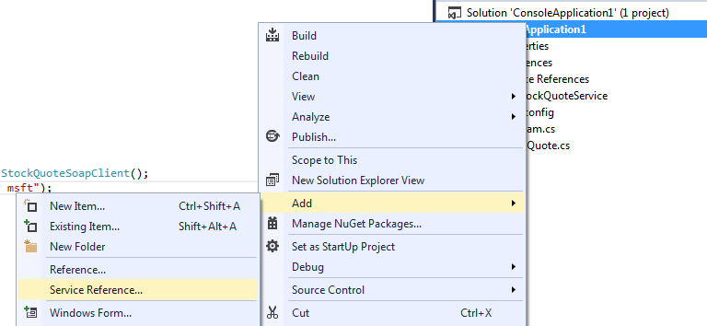

* On Add Service Reference window, enter service address and click on Go button .

Under Namespace you can provide name of service namespace as per your choice.

Click OK.

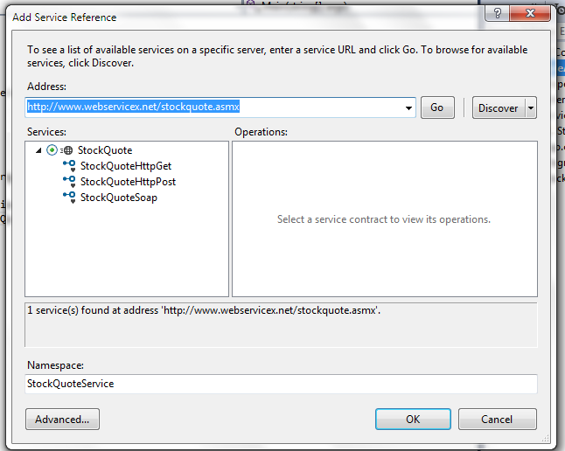

**Step 2. Service call from code to get XML response and generate Model class from xml**

* Add Service Namespace

using ConsoleApplication1.StockQuoteService;

* Call the service method.

StockQuoteSoapClient client = new StockQuoteSoapClient();

var result = client.GetQuote("ibm, msft");

* Copy value of ‘result’ variable.
* Add new class as ‘StockQuotes.cs’
* Delete all content from ‘StockQuotes.cs’
* From Edit menu select –> Paste Special -> Paste XML as Class

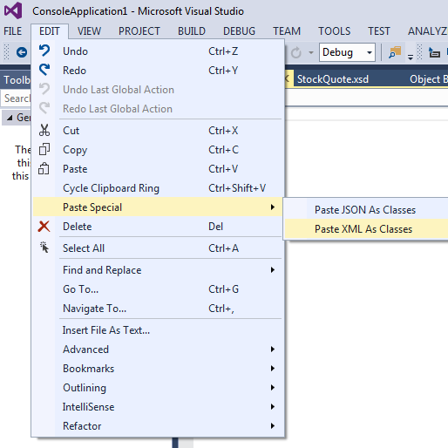

* It will create model class for XML. Save changes.

**Step 3. Using serialization to populate model from service response.**

* Add namespace for xml serialization

using System.Xml.Serialization;

* Initialize xml serializer with the type of model. ‘StockQuotes’ is the model in our case.

XmlSerializer serializer = new XmlSerializer(typeof(StockQuotes));

* Add code to populate model:

Add reference to Sytem.IO to use TextReader, it contains XML string and it will be passed to Deserialize method as parameter.

using (TextReader reader = new StringReader(result))

{

stockQuotes = (StockQuotes)serializer.Deserialize(reader);

}

We are using Deserialize method of XmlSerializer to parse XML response received from service.

It fills up the model ‘StockQuotes’ with the XML response from the service.

* We can now use this as per our need

//stockQuotes contains array of StockQuotesStock class in Stock property

//so we loop through each

foreach (var stockquote in stockQuotes.Stock)

{

var name = stockquote.Name;

}

Below is the full code with comments :

**Here is full code with comments:**

static void Main(string[] args)

{

// service client instantiation

StockQuoteSoapClient client = new StockQuoteSoapClient();

// service call

var result = client.GetQuote("ibm, msft");

// instantiate serializer

XmlSerializer serializer = new XmlSerializer(typeof(StockQuotes));

StockQuotes stockQuotes;

// Read results to a reader

using (TextReader reader = new StringReader(result))

{

// We are doing DESERIALIZING opertion of XML Serializer.

// As we are receiving serialized response from service we have to desirialize it to populate Model

stockQuotes = (StockQuotes)serializer.Deserialize(reader);

}

// check for null to avoid exception

if (stockQuotes != null)

{

//stockQuotes contains array of StockQuotesStock class in Stock property

//so we loop through each

foreach (var stockquote in stockQuotes.Stock)

{

var name = stockquote.Name;

}

}

}